Past and Future changes of Growing Season Length over India in General Circulation Model

Rimjhim Goel (MS18133)

Abstract

Trends of the Thermal Growing Season Length Index (GSL) over Indian region are studied and compared for the historical period from 1850-2014 and the future period from 2015-2100. Trend analysis is done using three attributes: the Spatial Plot of the climatology of GSL, Spatial trend of GSL and Area averaged Time series of GSL over five major divisions of Indian subcontinent (Northern, Southern, Eastern, Western and Central). Time series of GSL for the whole duration from 1850-2100 is also plotted for three major cities of India: Delhi, Mumbai and Kolkata.

Introduction and Motivation

The length of the growing season in any given region refers to the number of days when plant growth takes place. The growing season often determines which crops can be grown in an area, as some crops require long growing seasons, while others mature rapidly. Growing season length is limited by many different factors. Depending on the region and the climate, the degree of interannual variability in GSL is influenced by factors such as air temperatures, frost days, rainfall, or daylight hours.

Within a period of 12 months, the thermal growing season length (GSL) is calculated as the number of days between the first occurence of atleast 5-day period with daily mean temperatures above 5°C and the first occurrence of 5-day period with temperatures below 5°C. On Northern hemisphere, this period corresponds with the regular year, whereas on Southern Hemisphere, it starts at July 1st.

Changes in the length of the growing season can have both positive and negative effects on the yield and prices of particular crops. Overall, global warming is expected to have negative effects on yields of major crops, but crops in some individual locations may benefit. A longer growing season could allow farmers to diversify crops or have multiple harvests from the same plot. However, it could also limit the types of crops grown, encourage invasive species or weed growth, or increase demand for irrigation. A longer growing season could also disrupt the function and structure of a region’s ecosystems and could, for example, alter the range and types of animal species in the area.

Data and Methods

All the plots are based on temperature data compiled by the National Oceanic and Atmospheric Administration’s National Centers for Environmental Information, through the Coupled Model Intercomparison Project (CMIP), the recently developed CMIP6, in particular. These data are available online at: [www.ncei.noaa.gov](https://www.ncei.noaa.gov/).

We have generated three types of plots for our analysis.

1) Spatial plots of climatology

These plots simply show the time mean of the index for each grid point.

2) Spatial trend Plots

Trend is the rate at which the length of growing season changes over time. This kind of plots indicate the rate of change the GSL index values change over each grid point.

3) Time Series Plots with slope and p-values

Time series plots indicate how the length of the growing season varies over the concerned region with respect to time. We calculate the slope of the line fit to the time series by using the simple linear regression. We also calculate the p-values. A p-value less than 0.05 means that deviation from the null hypothesis (that there is no change in values of GSL index over time) is statistically significant, and the null hypothesis is rejected.

Results For Historical Data (1850-2014)

Que1. a) Spatial Plot

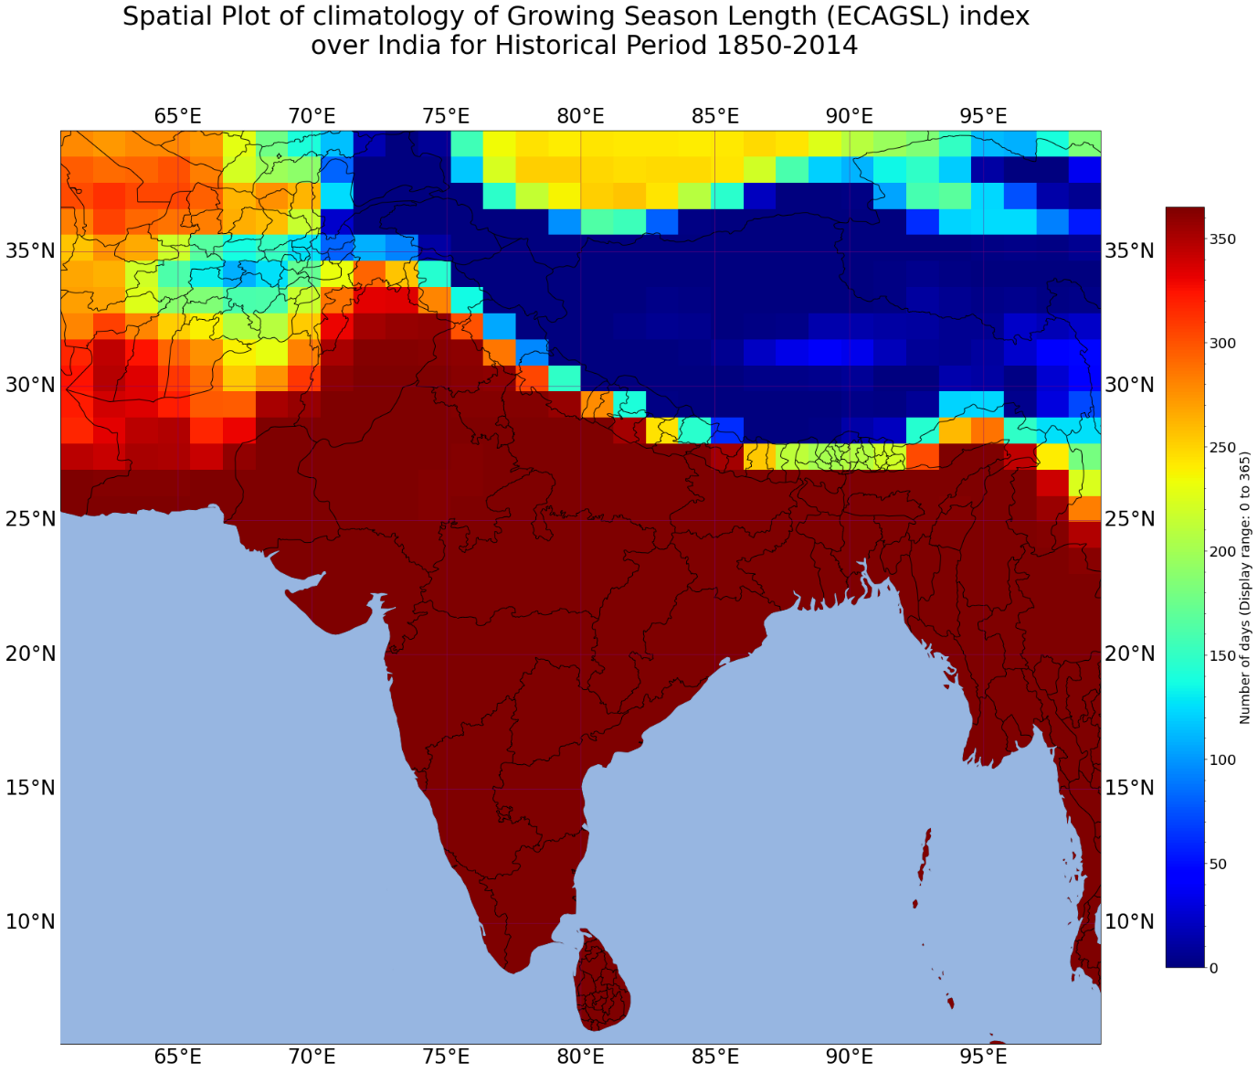

From this plot, we can see that for most parts of India, the entire year is the growing season. The conditions are never very extreme (like frost days) making the cultivation entirely impossible. In the north region, as one moves up towards the Himalayan belt, the growing season becomes shorter and shorter and negligible for a significant part of the belt. This region is snow-clad throughout the year and supports only tundra vegetation. Cultivation of any commercial crop is hardly seen. As the regions become warmer, vegetation start appearing.

Que1. B) Spatial trend Plot

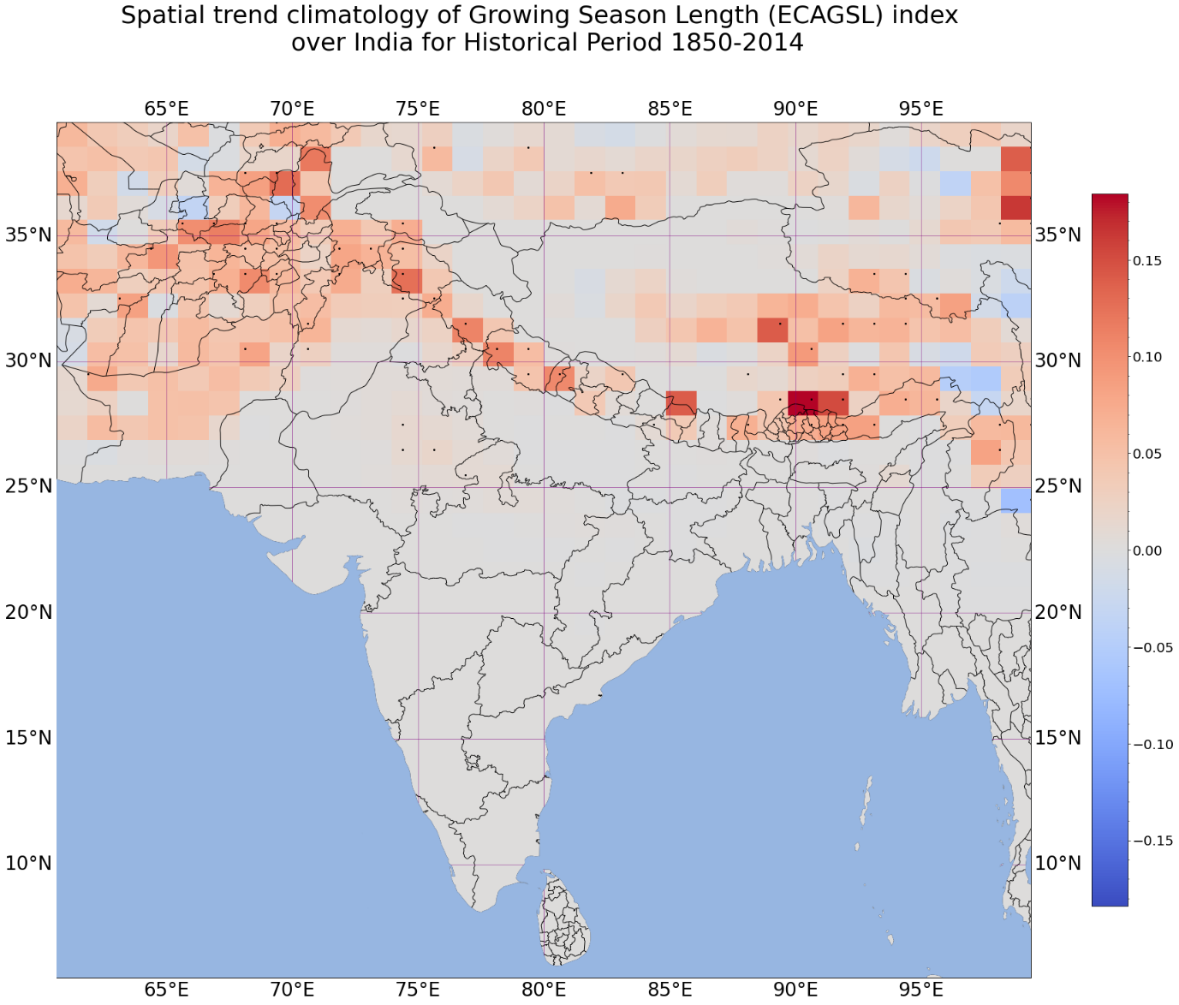

The spatial trend graph indicates that the length of growing season in India has not changed much over time. Only a few North region states registered a growing trend. Negative trend is nowhere to be seen.

Que1. c) Area Averaged Time Series for Historical Data

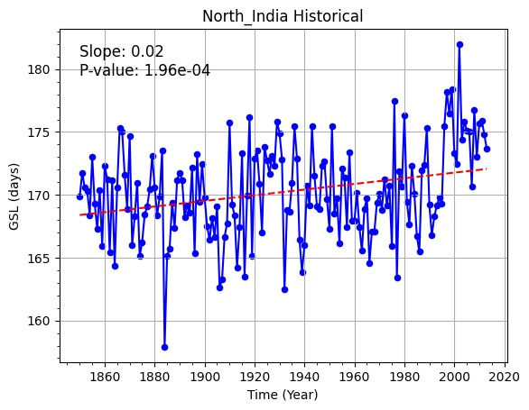

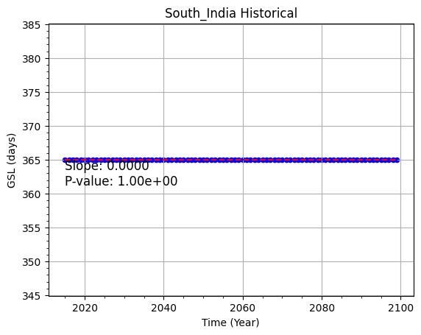

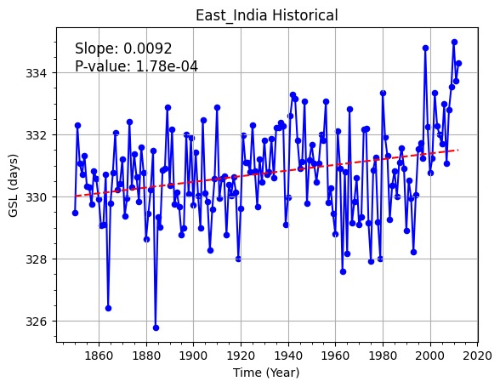

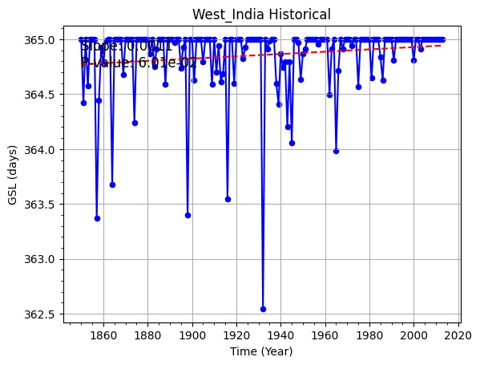

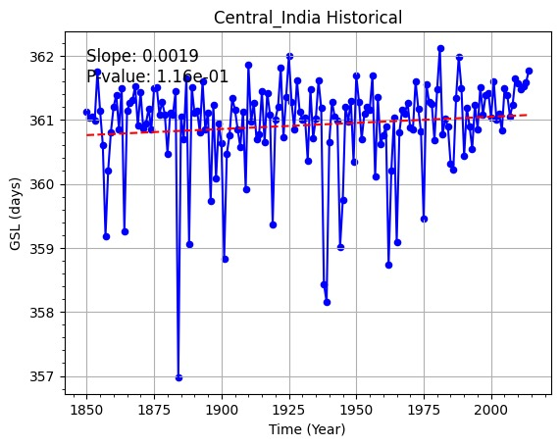

GSL values in South Indian region has been 365 days since the start to the end of the historical period. This region hardly experiences the daily minimum temperature values of less than 5 degree celsius, let alone the mean temperature.

For North and East India, there is an increasing trend with positive slope. Also the p-value is of order -4, significantly less than 0.05. Thus the change value is statistically significant.

For West and Central India, the slope is positive so the trend is increasing. But the p-values are greater than 0.05, which means that the confidence value is less 95%.

The contrast between North and East versus West and Central India is that although the growing season lengths increase, the former experiences much more variation compared to a 3-4 days variation for the later. This might be attribute to the locations, topography distance from sea for these regions.

Results on Future data

Que2. Spatial climatology for Future Period(2015-2100)

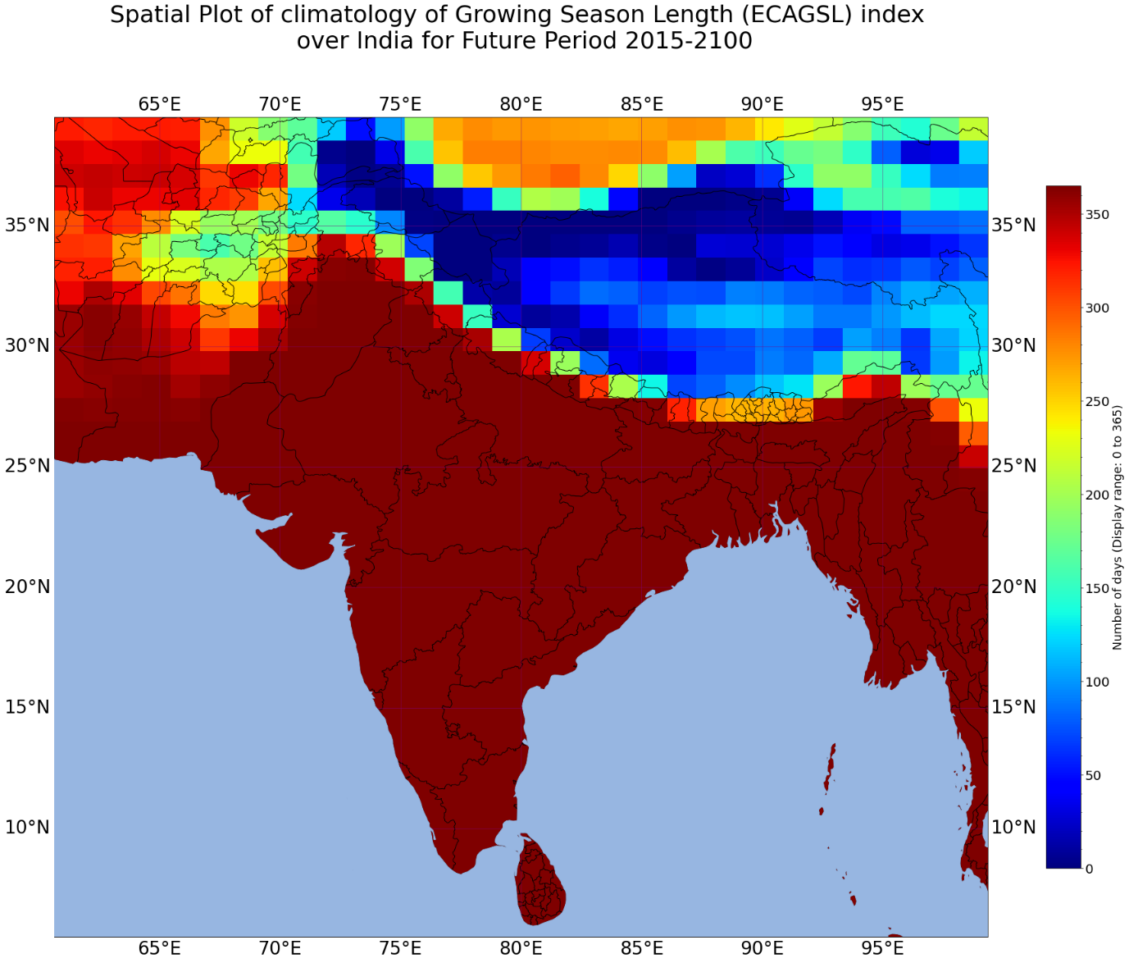

The spatial plot for future is also very similar to that for historical period. Most of the regions still have a whole year of growing season.The North part of the country, specially the Himalayan belt show slighty less than a year of growing season. The characteristic to note is that, the length has overall increased. The regions have risen up in the colour bar compared to the historical data.

Que2. Spatial trend plot for future

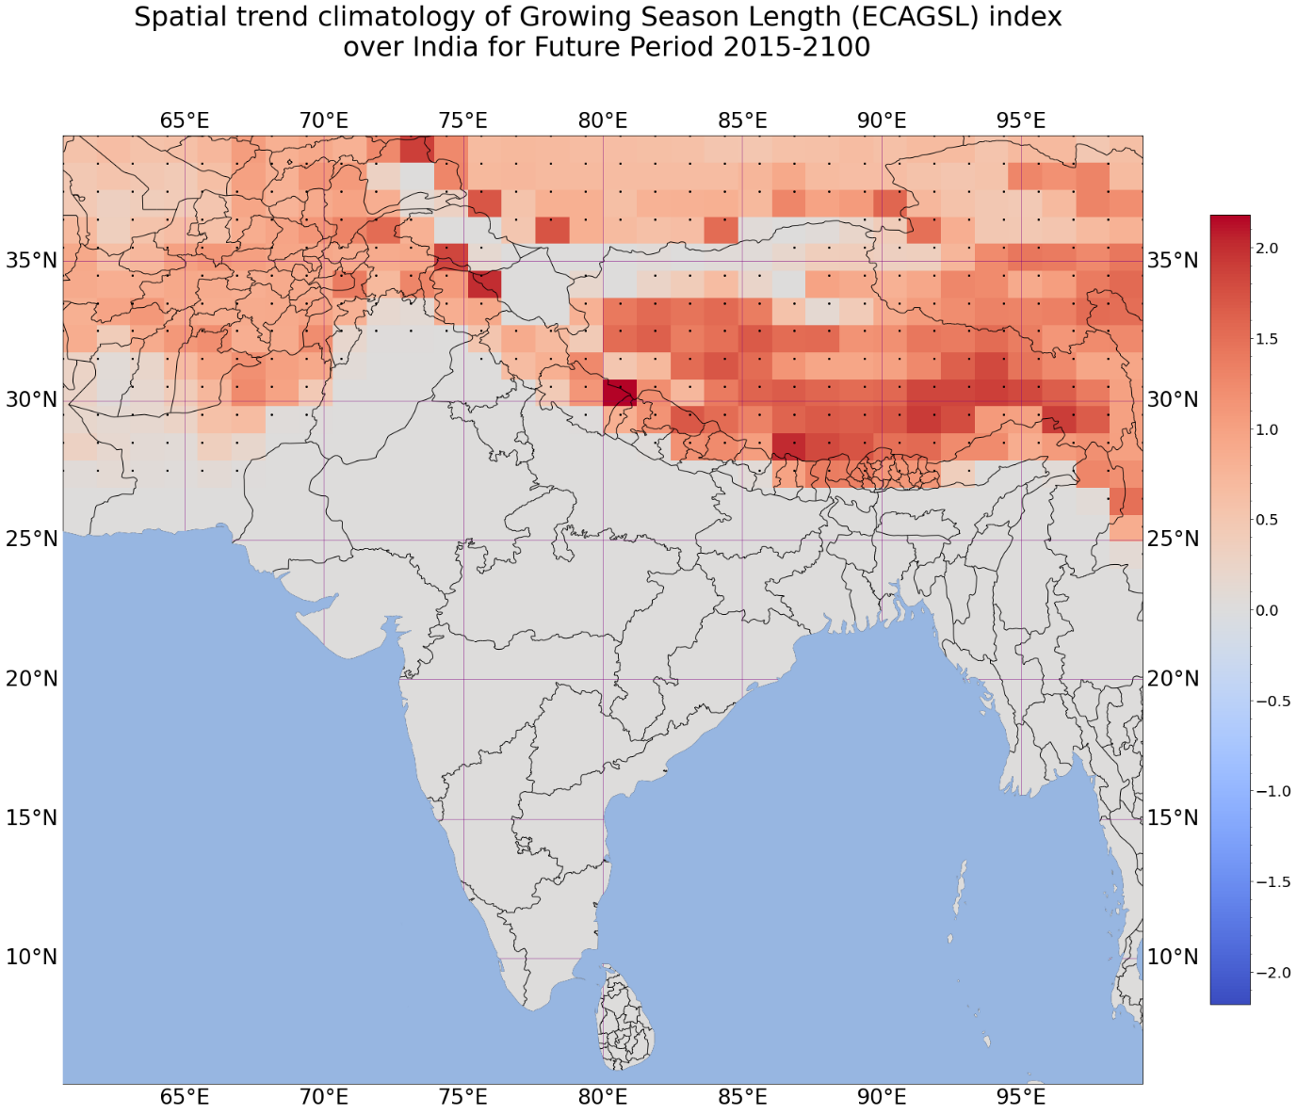

This plot is also similar to trends in history in the sense that the regions only show a positive trend, never decreasing and those that have no trend continue to show no trend. The noteworthy difference is that the trend values have gone up, overall. There are more darker regions this time.

Que2. C) Time series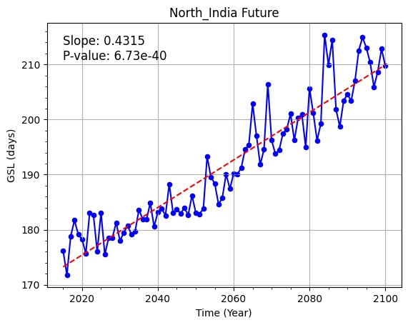

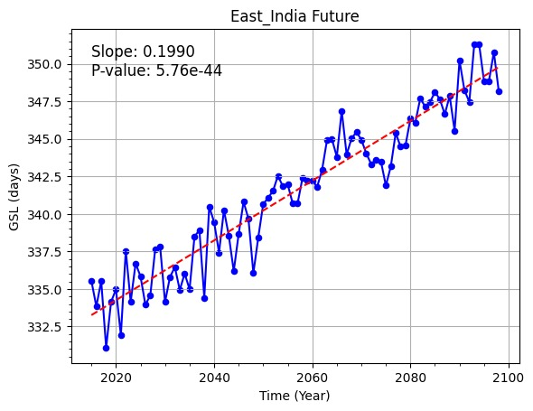

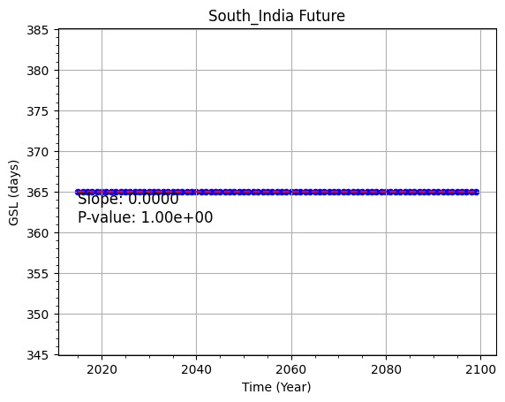

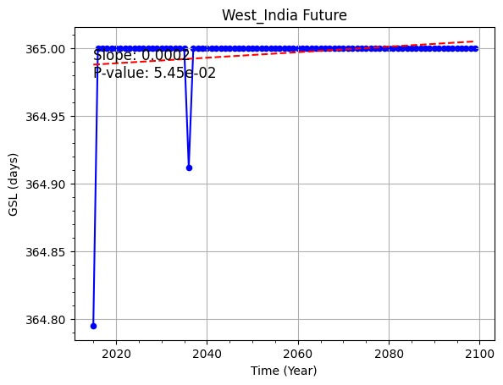

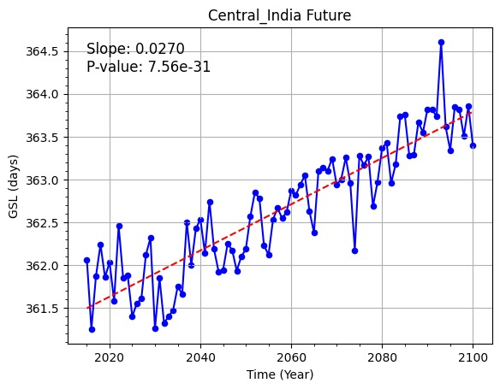

The South region shows zero slope, as one would expect. West region also shows almost no change because just two values are slightly less than 365. To say that the trend is increasing, wont be justified.

For the other three regions, the slope is positive, indicator of increasing trend. The p-values are all significantly less than 0.05 , further confirming this hypothesis.

Que3. d) Major cities (Kolkata, Delhi and Mumbai)

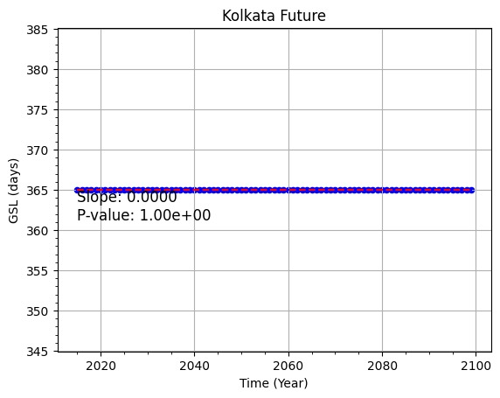

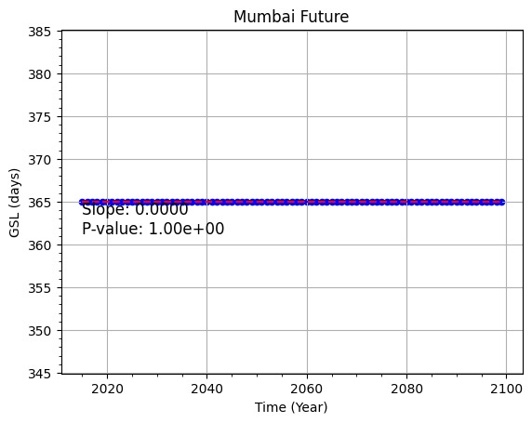

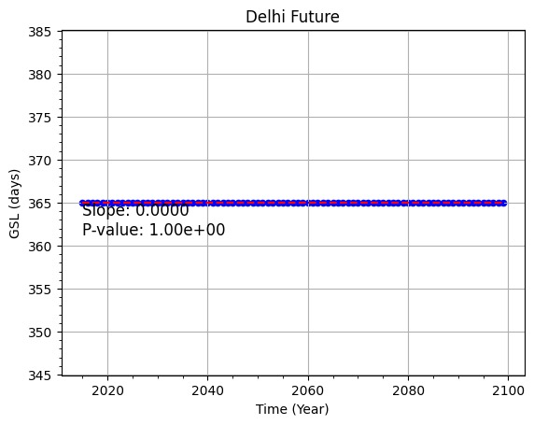

All the three of our major cities show a full year of growing season. For Mumbai and Kolkata, this is understandable, because the regions they belong to have shown similar results. But Delhi being a North Indian city, this was not expected. An important fact is that, whereas historical data for Mumbai and Kolkata is the same, Delhi historically was not the same. It showed a slightly less longer growing season (with an increasing trend).

Conclusions

The analysis of the plots indicates that most part of India experiences a growing season throughout the year and the regions which don’t, are going to experience a longer growing season in the future with a confidence level of more than 95%. One of the possible reasons for this could be the increasing level of global warming on the planet because the index GSL uses the daily mean temperatures to calculate the growing seasons length. The increase in mean temperature although on one hand ensures longer growing season, it also implies higher chances of heat damage. The crop varieties with tolerance for temperature are more likely to benefit in the coming years.

References

1) Climate change indicators on epa.gov.

2) INCREASING GROWING-SEASON LENGTH IN ILLINOIS DURING THE 20TH CENTURY SCOTT M. ROBESON.

3) IPCC reports on GSL.

4) Details of the index on Copernicus.edu.